# CS 340 README

## About Project 2: Grazio Salvare Database

This is a project using the PyMongo driver to create CRUD functional access to data from five Austin, Texas animal shelters to help Grazioso Salvare identify dogs who are good candidates for their search-and-rescue training program.

## Motivation

This project exists to help Grazioso Salvare sort through animal shelter data to find dogs who are good candidates for search-and-rescue training based on certain provided criteria. MongoDB was chosen as it is good at storing and working with large amounts of text. Python allows us more backend web development options and Dash framework allows us to create our interactive user interfaces.

## Getting Started

To run this project one would need the journal (Project2.ipynb) file, the Python CRUD file (animal_shelter.py), and Grazioso Salvare Logo file in one folder. From there Mongo would need to be opened up in the terminal and the csv file from the shelter would need to be imported. After that, open the journal and run the first python cell.

## Installation

Jupyter Notebook from <https://jupyter.org/>

MongoDB from <https://www.mongodb.com/docs/manual/installation/>

## Usage

First our data is read in through our CRUD file and then displayed in a table as well as a graph showing the distribution of breeds. From there we can use different filtering options to find dogs who will match the criteria given by Grazioso Salvare for different types of rescues.

Filter for dogs who fit the criteria for water rescue training

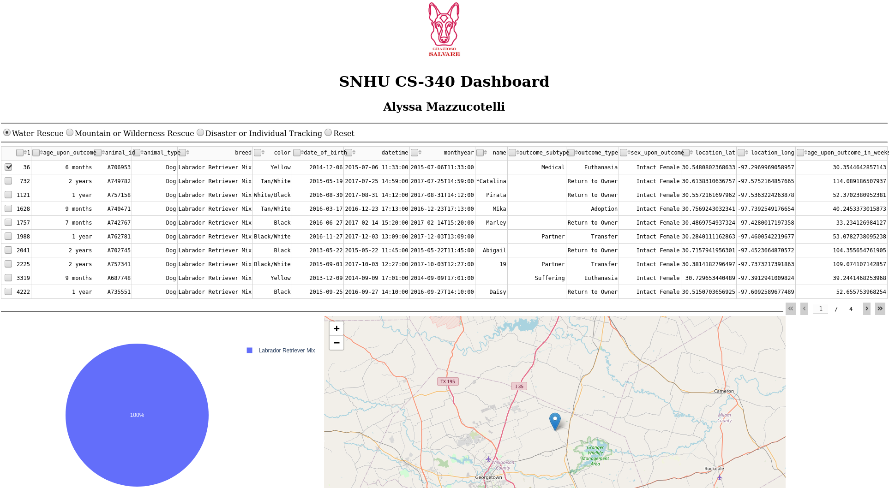

Filter for dogs who fit the criteria for mountain or wilderness rescue training

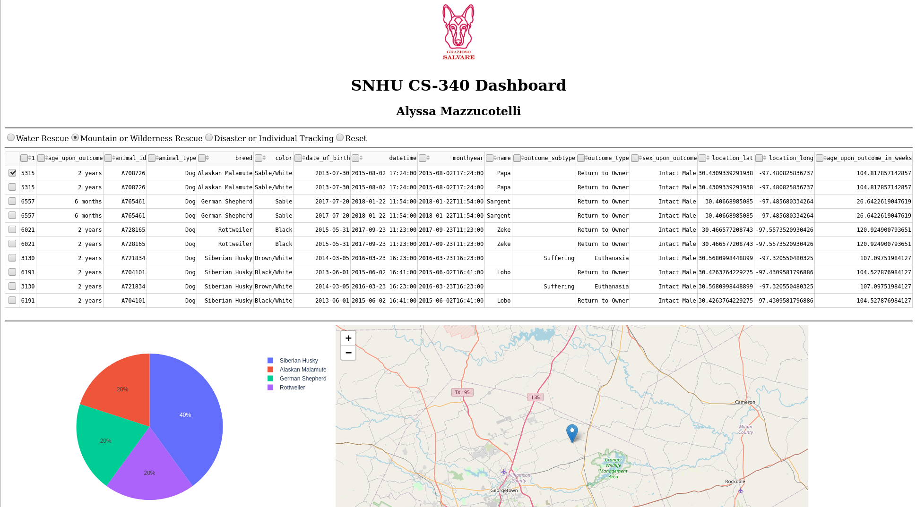

Filter for dogs who fit the criteria for disaster or Individual tracking training

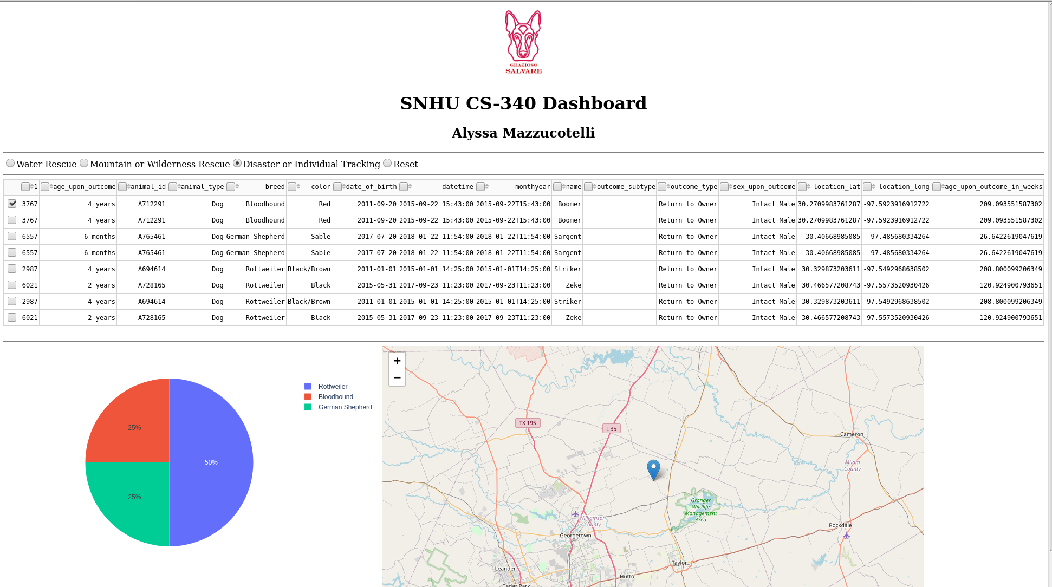

Resetting the filter to see all animals at the shelter

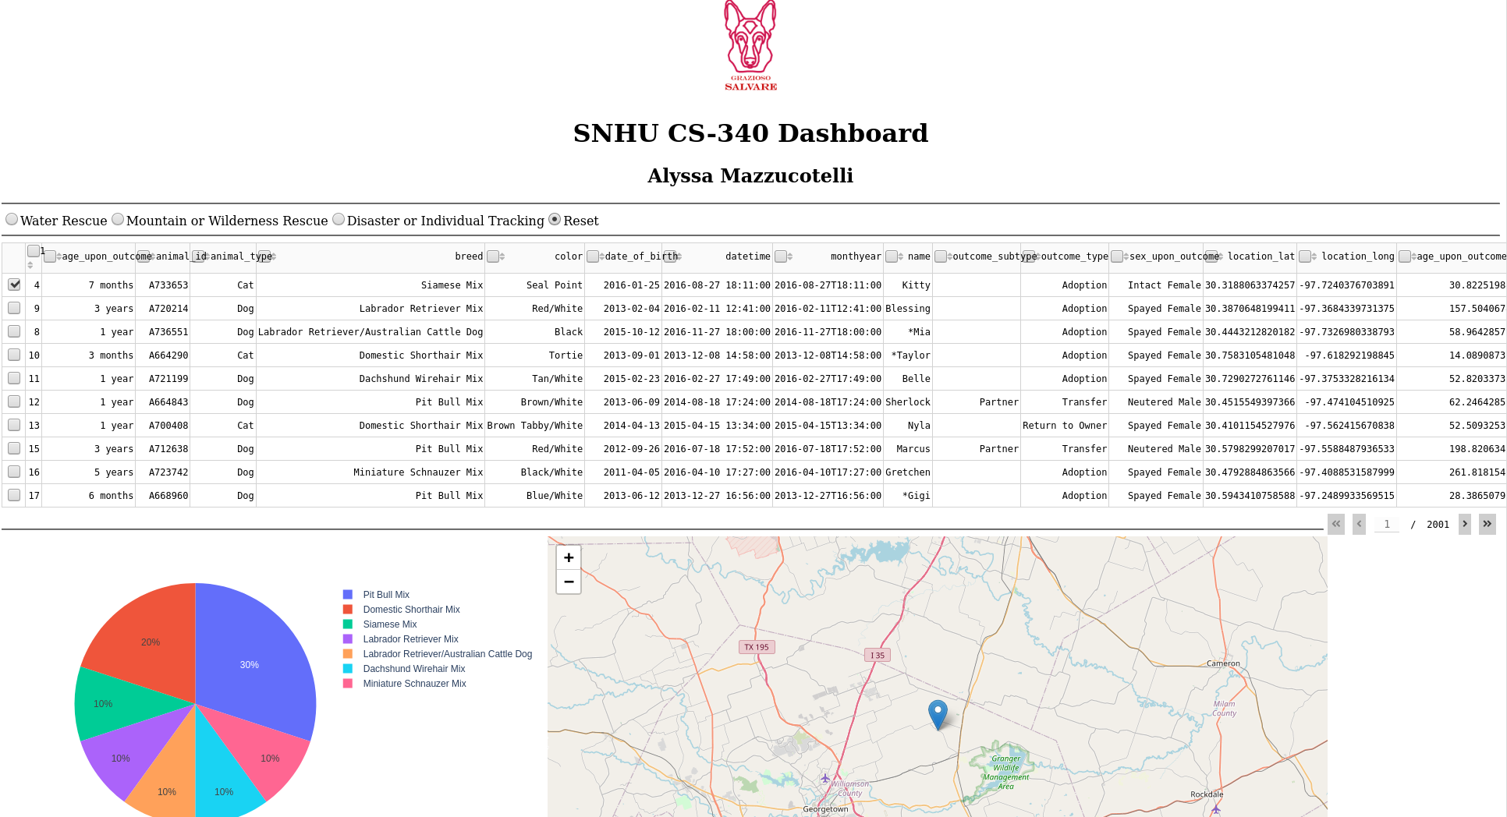

## Features

Features include

* Grazioso Salvare branding
* A data table that dynamically responds to filter options
* Filters to see dogs who are candidates for
  + Water Rescue
  + Mountain or Wilderness Rescue
  + Disaster or Individual Tracking
* A rest filter option
* Graph of breed types
* Geolocation map of animal location

## Contact

Your name: Alyssa Mazzucotelli